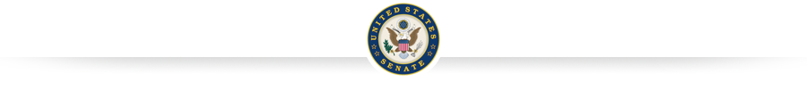

**Delaware FY2019 Appropriations Request Form**

Individuals and organizations from Delaware wishing to request congressional appropriations should complete the form below digitally in Microsoft Word for each appropriations request and submit to: [appropriations@coons.senate.gov](mailto:appropriations@coons.senate.gov). Additional information may be requested throughout the appropriations process to help understand, clarify or justify your program request. Please ensure your contact email and phone numbers are correct. The due date for the forms is Monday, March 26.

**About the Applicant**

Organization Name: Click here to enter text.

Point of Contact: Click here to enter text.

Address: Click here to enter text.

City: Click here to enter text.

State: Click here to enter text.

Zip: Click here to enter text.

Phone: Click here to enter text.

Email: Click here to enter text.

**Program**

1 . Program title or area: Click here to enter text.

2a. Under which federal agency and office does this program fall? Click here to enter text.

2b. Under Which Appropriations subcommittee and account does this federal program (*if known)*? Click here to enter text.

3. Summary of program requests (*provide narrative description, including specific benefits to Delaware*): Click here to enter text.

4. Prior program funding levels: FY2017$ Click here to enter text. FY2018$ (if possible) Click here to enter text.

**Appropriations Request**

5a. Which type of request are you making?  Programmatic funding  Language

*If you answered “Programmatic funding,” please proceed to 5b. If you answered “Language,” please skip to 5c.*

5b. Please check one of the following boxes indicating the funding level you are requesting for this federal program in FY2019:

President’s FY2019 budget request  The FY2018 enacted level (if known)

New funding level request: $ Click here to enter text.  General support for the program

5c. Please attach or provide below the language you wish to be included in the FY2019 appropriations bill.

Bill Language  Report Language

Proposed language (*if not attached*): Click here to enter text.

6. If this is a defense-related request, please provide the appropriate line number of Program Element (PE) number there. Click here to enter text.

7. If you are submitting more than one request, please list the appropriations requests in priority order from highest to lowest (*i.e. 1 of 3*) Click here to enter text.

*Disclaimer – By providing the above information, I understand that this is informational purposed only and is not, of itself, an application for federal funding. Submission of this information does not constitute a binding commitment on any party nor a guarantee that any organization will be awarded funding from any federal agency through this process. Furthermore, I understand that the submission, review, and approval of applications for federal funding will be carried out consistent with federal agency rules and regulations.*

**SUBMITTED BY:**

Name: Click here to enter text.

Date: Click here to enter text.